

**ABESIT COLLEGE OF ENGINEERING,**

**GHAZIABAD**

REPORT

On

**“WEATHER FORECASTING USING AI”**

For Mini Project Assessment

Third Semester-(KCS 354)

(2021-22)

**Department of Information Technology**

Submitted by: Under the Supervision of :

**Khushi Sharma(2002900130026) Prof. Rishabh Kamal**

**INDEX**

Declaration………………………………………………………………………..

Certificate… ........................................................................................................

1. Introduction………………………………………………………………
2. Mini Project Objective …………………………………………………..
3. Tools and Techniques used for the Mini Project…………………………
4. Methodology……………………………………………………………...
5. Implementation…………………………………………………………..
6. Results…………………………………………………………………...
7. References……………………………………………………………………………………………
8. Internship Trading Details……………………………………………………………………

**DECLARATION:**

This is to certify that the Mini Project report entitled “Weather Forecasting using AI” is an authentic work carried out by us in the fulfillment of the requirements for the Internship Assessment under the guidance of Prof. Rishabh Kamal.

Signature: Khushi Sharma

Name: Khushi Sharma

Roll No.: 2002900130026

Date: 03/02/2022

Place: Ghaziabad

**CERTIFICATE:**

This is to certify that project entitled **“Weather Forecasting using AI”** is submitted in the fulfillment of the requirement for the Internship Assessment in the Department of Information Technology, from ABESIT College of Engineering Ghaziabad, affiliated to the **Dr. A.P.J ABDUL KALAM TECHNICAL UNIVERSITY, LUCKNOW, UTTAR PRADESH.**

Mini Project Coordinator:

Prof. Rishabh Kamal.

1. **INTRODUCTION**

There are several reasons why weather forecasts are important. They would certainly be missed if they were not there. It is a product of science that impacts the lives of many people. The following is a list of various reasons why weather forecasts are important:  
**1**. Helps people prepare for how to dress (i.e. warm weather, cold weather, windy

weather, rainy weather).  
**2**. Helps businesses and people plan for power production and how much power to use (i.e. power

companies, where to set thermostat).  
**3**. Helps people prepare if they need to take extra gear to prepare for the weather (i.e. umbrella,

raincoat, sunscreen).  
**4**. Helps people plan outdoor activities (i.e. to see if rain/storms/cold weather will impact outdoor

events).  
**5**. Helps curious people to know what sort of weather can be expected (i.e. snow on the way,

severe storms).  
**6**. Helps businesses plan for transportation hazards that can result from the weather (i.e. fog,

snow, ice, storms, clouds as it relates to driving and flying for example).  
**7**. Helps people with health-related issues to plan the day (i.e. allergies, asthma, heat stress).  
**8**. Helps businesses and people plan for severe weather and other weather hazards (lightning, hail,

tornadoes, hurricanes, ice storms).  
**9**. Helps farmers and gardeners plan for crop irrigation and protection (irrigation scheduling,

freeze protection).

1. **OBJECTIVE**

The project aims and objectives that will be achieved after the completion of this project are discussed in this subchapter. The aims and objectives are as follows:

* To reduce weather-related losses.
* To observe pattern events, also termed pattern recognition.

The goal of weather prediction is to provide information to the people and organizations that can use to reduce weather-related losses and enhance societal benefits, including protection of life and property, public health and safety, and support of economic prosperity and quality of life.

1. **TOOLS AND TECHNIQUES USED FOR THE PROJECT:**

**Python**

**VS Code**

**Machine Learning**

* TensorFlow
* Scikit-learn
* NumPy
* Pandas
* Series
* Data Frame
* Panel

1. **METHODOLOGY:**

Of course, for the weather forecast to exist, there must be methods to do it. These methods are as follows:

**Persistence forecasting**

Persistence forecasting is the easiest method of forecasting which assumes a continuation of the present. It relies upon today’s conditions to forecast the weather when it is steady state, such as during the summer season in the tropics. This method of forecasting strongly depends upon the presence of a stagnant weather pattern. It can be useful in both short-range forecasts and long-range forecasts

**Climatology forecasting:**

Whereas persistence forecasting is most accurate over short periods (before factors for change have had time to operate), the best estimate of the weather a long time ahead is the average value of past measurements there at that time of day and year. Climatology forecast relies on the observation that weather for a particular day at a location does not change much from one year to the next. As a result, a long-term average of weather on a certain day or month should be a good guess as to the weather for that day or month. The most obvious climatology forecast in this part of the world (Nigeria) is, “Cold in December, warm in July (the popular July break)”. One does not need to be a meteorologist to make that forecast.

**Looking at the sky:**

Along with pressure tendency, the use of the sky condition is one of the more important weather parameters that can be used to forecast weather in mountainous areas. Thickening of cloud cover or the invasion of a higher cloud deck is indicative of rain shortly. Morning fog portends fair conditions, as rainy conditions are preceded by wind or clouds, which prevent fog formation. The approach of a line of thunderstorms could indicate the approach of a cold front. Cloud-free skies are indicative of fair weather for the near future. The use of sky cover in weather prediction has led to various weather lore over the centuries.

**Use Of Barometer:**

Using barometric pressure and the pressure tendency (the change of pressure over time) has been used in forecasting since the late 19th century. The larger the change in pressure, especially, if more than 2.54mmHg, the larger the change in weather can be expected. If the pressure drop is rapid, a low-pressure system is approaching, and there is a greater chance of rain. Rapid pressure rises are associated with improving weather conditions, such as clearing skies.

**Nowcasting:**

Severe weather is typically short-lived (less than two hours) and, due to its mesoscale character (less than one hundred kilometers), it affects local/regional areas necessitating site-specific forecasts. This category includes thunderstorms, gust fronts, tornadoes, high winds especially along coasts, over lakes and mountains, heavy snow, and freezing precipitation. The development of radar networks, new instruments, and high-speed communication links has provided a means of issuing warnings of such phenomena.

**Use of Forecasting Models:**

In the past, human forecasters were responsible for generating the entire weather forecast based upon available observation. Today, human input is generally confined to choosing a model based on various parameters, such as model biases and performance. Using a consensus of forecast models and ensemble members of the various models can help reduce forecast error. However, regardless of how small the average error becomes with any individual system, large errors within any particular piece of guidance are still possible on any given model run. Humans can use knowledge of local effects, which may be too small in size to be resolved by the model to add information to the forecast.

**Analog Forecasting:**

The analogue method is a complex way of making a forecast, requiring the forecaster to remember a

previous weather event that is expected to be mimicked by an upcoming event. The analogue forecaster’s task is to locate the date in history when the weather is a perfect match, or analogue, to today’s weather. Then the forecast for tomorrow is simple – whatever happened on the day after the analogue will be the weather for tomorrow. The forecast for the day after tomorrow is whatever happened on the second day after the analogue, and so forth.

**Ensemble Forecasting:**

Although a forecast model will predict weather features evolving realistically into the distant future, the errors in a forecast will inevitably grow with time due to the chaotic nature of the atmosphere and the inexactness of the initial observations. The detail that can be given in a forecast, therefore, decreases with time as these errors increase. These become a point when the errors are so large that the forecast does not correlate with the actual state of the atmosphere. Ensemble forecasts are increasingly being used for operational weather forecasting. Ensemble forecasting requires a sophisticated understanding of the atmosphere and computer models.

## **IMPLEMENTATION**

We present the results of the live analysis performed with the help of API. We bring up the instances with the Nowcasting image and start the ingest of weather data through API. Once the cloud-based now cast instance receives the first set of scans, it starts to generate 1 to 15 minutes.

We carry out this operation for one hour of weather data and determine the cost for one hour. Nowcast operation using cost tracking services provided by **Amazon EC2**. We can do the liver measurement on each of four cloud instances for calculating the overall time taken for the nowcasting process. This process is suitable for cloud-cast applications on cloud services.

Data is transmitted to a particular instance by the execution of the algorithm within 15 minutes. Nowcast images are generated and are sent to a central web server that is used by the client. Here **Amazon EC2** is a cloud service that provides resizable compute capacity to execute applications on demand. EC2 provides on-demand resources with pricing depending on the type of resources used and duration of usage.

1. **RESULTS (SCREENSHOTS):**

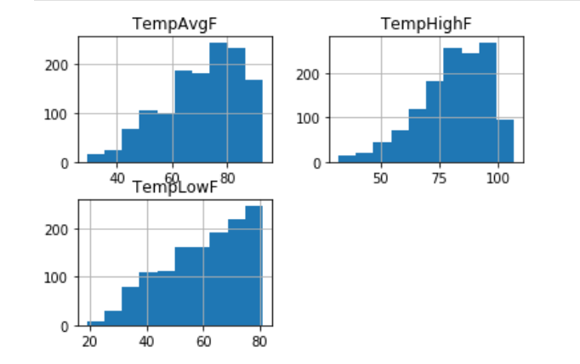

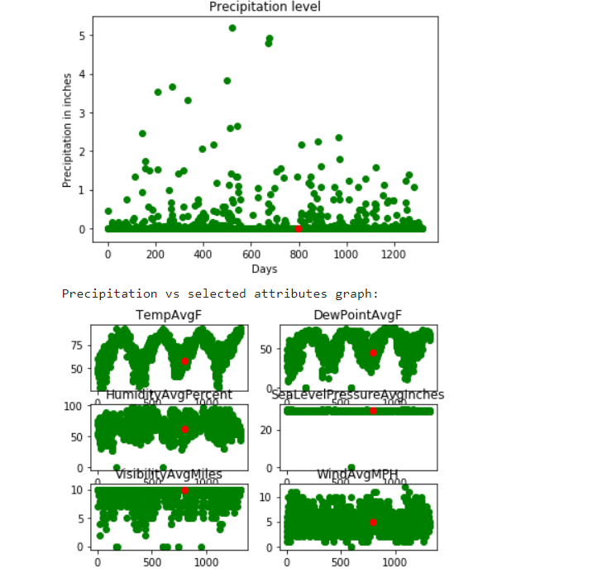

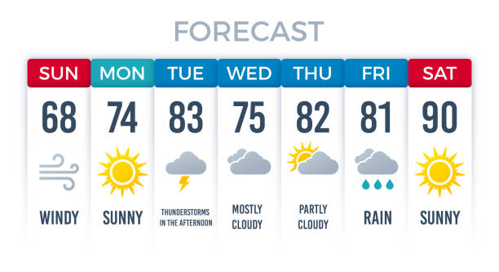

1. **REFERENCES:**

1. **Meghali A.Kalyankar, Prof.S.J.Alaspurkar,** “Data Mining Technique to analyze the Metrological Data, International Journal of Advanced Research in Computer science and Software Engineering, Volume 3 Issue 2, February 2013.
2. **Ghil, M and P.P Malanotte-Rizzoli** Data assimilation in meteorology and oceanography.Adv.Geophys.,33,141-266.
3. **Glahn, B. Comments-Reforecas**t: An important data set for improving weather prediction **Bull**. **Amer. Meteo.** Soc. 89, 1373-1378.
4. **Hanson C.E., J.P. Palutik of, M.T.J. Livermore**, et al. Modeling the impact of climate extremes: an overview of the MICE project. Climate change, 81, 163-177.
5. **Heintzenberg, J. and R.J. Charlson (2007**). Clouds in the perturbed Climate System: Their relationship to energy balance, Atmospheric Dynamics and precipitation Cambridge, USA: MIT Press.
6. **P.Rajarajeswari, Dr. A.Ramamohanreddy, Dr. D.Vasumathi** “Problem Solving Process Based on Conceptual model with Mathematical Techniques, “International Journal of Computer & Mathematical Sciences ISSN 2347 – 8527 Volume 3, Issue 6 August 2014.
7. **INTERNSHIP TRAINING DETAILS:**

